Hillcrest Early Years Academy



Special Educational Needs and Disabilities Policy

Produced By | Chris Inman
Date Produced | September 2025
Approved By | Board of Trustees
Date Approved
Review Due

Contents

1. Aims
2. Legislation and Guidance
3. Definitions
4. Roles and Responsibilities
5. SEN information report
6. Monitoring arrangements
7. Links with other Policies and Documents

Aims
Our SEN policy and information report aims to:
- At Hillcrest Academy we regard every child as having individual needs. Each pupil will have an equal opportunity to work to their full potential so that they will learn to appreciate and value their own strengths. We aim to ensure that each pupil feels equally valued within the academy community by formulating as truly a comprehensive and far- reaching practical curriculum as possible and by our ethos, values and attitudes.
- It is estimated that approximately 20% of pupils may experience learning difficulties at some point during their education. These difficulties may be short or long term and may include one or more of the following areas: intellectual, physical, sensory, social, emotional, behavioural, or speech and language.

Our Special Educational Needs Policy aims to meet those difficulties by:

- Identifying pupils with special educational needs promptly.
- Enabling all staff to meet identified pupil needs and keep up with developments in areas of special educational needs.
- Making the curriculum accessible to all pupils through recognising the need for differentiation and employing a range of teaching styles.
- By working closely with parents and outside agencies.
We believe there are considerable benefits for all pupils in catering for special educational needs in the mainstream class. Where in-class support is provided, teachers are better able to focus on differing levels of ability within the group. Some pupils with special educational needs, however, may at times require more specialised teaching which can better be provided within a small group or individual situation away from the main classroom.

Mr Chris Inman is the named SENCo for the academy, but as per the Code of Practice, every teacher is responsible for SEN. All staff have knowledge and understanding of SEN and receive regular training and support.

Legislation and guidance
This policy and information report is based on the statutory Special Educational Needs and Disability (SEND) Code of Practice and the following legislation:
- Part 3 of the Children and Families Act 2014, which sets out schools’ responsibilities for pupils with SEN and disabilities
- The Special Educational Needs and Disability Regulations 2014, which set out schools’ responsibilities for education, health and care (EHC) plans, SEN co-ordinators (SENCOs) and the SEN information report. This policy also complies with our funding agreement and articles of association.

Definitions
A pupil has SEN if they have a learning difficulty or disability which calls for special educational provision to be made for them.
A child has a learning difficulty or disability if they have:
- A significantly greater difficulty in learning than the majority of others of the same age, or
- A disability which prevents or hinders them from making use of facilities of a kind generally provided for others of the same age in mainstream schools.
Special educational provision is educational or training provision that is additional to, or different from, that made generally for other children or young people of the same age by mainstream schools.

Roles and responsibilities
The SENCO
The SENCO at Hillcrest is Mr Chris Inman
They will:
- Work with the Headteacher and SEN trustee to determine the strategic development of the SEN policy and provision in the school.
- Have day-to-day responsibility for the operation of this SEN policy and the co-ordination of specific provision made to support individual pupils with SEN, including those who have EHC plans.
- Provide professional guidance to colleagues and work with staff, parents, and other agencies to ensure that pupils with SEN receive appropriate support and high-quality teaching.
- Advise on the graduated approach to providing SEN support.
- Advise on the deployment of the school’s delegated budget and other resources to meet pupils’ needs effectively.
- Be the point of contact for external agencies, especially the local authority and its support services.
- Liaise with potential next providers of education to ensure pupils and their parents are informed about options and a smooth transition is planned.
- Work with the Headteacher and governing board to ensure that the school meets its responsibilities under the Equality Act 2010 regarding reasonable adjustments and access arrangements.
- Ensure the school keeps the records of all pupils with SEN up to date
The SEN trustee
The SEN trustee will:
- Help to raise awareness of SEN issues at meetings.
- Monitor the quality and effectiveness of SEN and disability provision within the school and update the governing board on this
Work with the Headteacher and SENCO to determine the strategic development of the SEN policy and provision in the school.

The Headteacher
The Headteacher will:
- Work with the SENCO and SEN trustee to determine the strategic development of the SEN policy and provision in the school.
- Have overall responsibility for the provision and progress of learners with SEN and/or a disability.

Class teachers
Each class teacher is responsible for:
- The progress and development of every pupil in their class.
- Working closely with any teaching assistants or specialist staff to plan and assess the impact of support and interventions and how they can be linked to classroom teaching.
- Working with the SENCO to review each pupil’s progress and development and decide on any changes to provision.
- Ensuring they follow this SEN policy.

SEN information report
The kinds of SEN that are provided for
Our school currently provides additional and/or different provision for a range of needs, including:
- Communication and interaction, for example, autistic spectrum disorder (ASD), and
speech and language difficulties.
- Cognition and learning, for example, dyslexia and dyspraxia.
- Social, emotional and mental health difficulties, for example, attention deficit hyperactivity disorder (ADHD).
- Sensory and/or physical needs, for example, visual impairments, hearing impairments, processing difficulties, and epilepsy.
- Moderate learning difficulties.
Identifying pupils with SEN and assessing their needs .
We will assess each pupil’s current skills and levels of attainment on entry, which will build on previous settings and Key Stages, where appropriate. Class teachers will make regular assessments of progress for all pupils and identify those whose progress:
- Is significantly slower than that of their peers starting from the same baseline
- Fails to match or better the child’s previous rate of progress
- Fails to close the attainment gap between the child and their peers
- Widens the attainment gap

This may include progress in areas other than attainment, for example, social needs.
Slow progress and low attainment will not automatically mean a pupil is recorded as having SEN.
When deciding whether special educational provision is required, we will start with the desired outcomes, including the expected progress and attainment, and the views and the wishes of the pupil and their parents. We will use this to determine the support that is needed and whether we can provide it by adapting our core offer, or whether something different or additional is needed.
The Academy has various tests which can also be used to assess a child’s abilities. The Academy buys in to the Specialist Teaching Service. The service is used to assess children, initially to identify weaknesses and needs. Further assessments are also used to identify some specific learning needs.

Consulting and involving pupils and parents
We will have an early discussion with the pupil and their parents when identifying whether they need special educational provision. These conversations will make sure that:
- Everyone develops a good understanding of the pupil’s areas of strength and difficulty.
- Pupil and parent voice is valued.
- Everyone understands the agreed outcomes sought for the child.
- Everyone is clear on what the next steps are.
Notes of these early discussions will be added to the pupil’s record by the class teacher and any relevant documentation such as Individual Education Plans, will be given to the pupils parents.
We will formally notify parents when it is decided that a pupil will receive SEN support.
- To enable continuity of learning and support, we liaise with other local nursery schools and our feeder junior school. To support pupil transitions, information is exchanged within face to face meetings and pupil records transferred to their new settings.
- Our Academy utilises the outside support and facilities of the Educational Psychology Service and Learning Pathways, Adviser and Advisory Teachers, Sensory Impaired Service, Speech and Language Therapy Service, Physiotherapist, Occupational Therapist, Social Services, Child and Adolescent Mental Health Service, Community Paediatrician and Educational Welfare Service. Our contact with these services varies depending on the needs of our individual pupils. The school SENCo conducts termly SEN planning meetings with some outside agencies to plan provision for identified children on the register.
- Our Academy believes in an equal partnership between teachers and parents in the education of its pupils. Teachers notify and involve parents when the school first becomes concerned about a pupil’s learning development and keeps them updated throughout the various stages or review. Our teachers value the opportunity to listen to parent’s concerns and discuss their child’s progress. Parents of pupils with SEN play a major part in the development of their child’s learning and may be asked to participate in home/school projects to meet the needs of their child. These may include reading, spelling, handwriting, number work and others. Parents are invited to contact the SENCO, the class teacher or the head teacher with SEN issues. Parents of pupils undergoing statutory assessment can receive further advice and support form the County Council Parent Partnership Officer.
We all value parents comments on all aspects of SEN within our academy, these include:
- How we can help parents to feel more confident in their contact with us.
- Way in which we can improve our arrangements on parental concerns.
- Our procedures for involving parents when concern is first expressed in school.
- Our arrangements for incorporating parents view in assessments and subsequent reviews.

- If a parent has a concern that has apparently not been noted in academy they should contact the SENCO. If the concern is not resolved to the satisfaction of the parent or SENCO it will be directed to the Principal. If a concern is not resolved it may be necessary for an examination of the complaint by the Board of Trustees. All complaints will be submitted following the complaints policy. If parents are in disagreement about pupil’s statement of SEN decided by the County Council a SEN tribunal considers appeals against them.

Assessing and reviewing pupils' progress towards outcomes
We will follow the graduated approach and the four-part cycle of assess, plan, do, review.
The class or subject teacher will work with the SENCO to carry out a clear analysis of the pupil’s
needs. This will draw on:
- The teacher’s assessment and experience of the pupil
- Their previous progress and attainment and behaviour
- Other teachers’ assessments, where relevant
- The individual’s development in comparison to their peers and national data
- The views and experience of parents
- The pupil’s own views
- Advice from external support services, if relevant The assessment will be reviewed regularly.
All teachers and support staff who work with the pupil will be made aware of their needs, the outcomes sought, the support provided, and any teaching strategies or approaches that are required. We will regularly review the effectiveness of the support and interventions and their impact on the pupil’s progress.
Supporting pupils moving between phases and preparing for adulthood
We will share information with the school, college, or other setting the pupil is moving to. We will agree with parents and pupils which information will be shared as part of this.
We work closely with the schools that your child will be attending to ensure they have a full understanding of your child’s needs. We will create a personalised transition plan for your child to ensure their needs are met. This could include additional meetings with the new school SENCo, additional transitional walk rounds with parents, additional transitional walk rounds with our staff or additional transition days both with peers and individually if required.

Our approach to teaching pupils with SEN
At Hillcrest Academy we regard every child as having individual needs. Each pupil will have an equal opportunity to work to their full potential so that they will learn to appreciate and value their own strengths. We aim to ensure that each pupil feels equally valued within the academy community by formulating as truly a comprehensive and far- reaching practical curriculum as possible and by our ethos, values and attitudes.
We believe there are considerable benefits for all pupils in catering for special educational needs in the mainstream class. Where in-class support is provided teachers are better able to focus on differing levels of ability within the group.

Some pupils with special educational needs, however, may at times require more specialised teaching which can better be provided within a small group or individual situation way from the main classroom.

Teachers are responsible and accountable for the progress and development of all the pupils in their class.
High quality teaching is our first step in responding to pupils who have SEN. This will be differentiated for individual pupils.
We will also provide the following interventions:
- Little Wandle Phonics interventions
- Precision Teaching
- Math’s Intervention
- Writing Intervention
- Motor Skill Intervention including Dough Disco
- Speech and Language including WELLCOM and Colourful Semantics.

Many interventions are planned around the needs of the child and as such interventions differ from class to class.
We work with many outside agencies and all suggestions from them are also planned in to the learning of the child as well as inn to interventions.
Adaptations to the curriculum and learning environment
Class teachers will provide the support required for both the more and less able pupils largely by the provision of differentiated material. The Teaching Assistants will provide some in-class support and 1:1/small group tuition for children on the SEN register in consultation with class teachers and the SENCO. Priority is given to those pupils with statements and those pupils with individual educational plans. Activities undertaken by the Teaching Assistants for children on the SEN register will be detailed on weekly plans.

Class teachers will ensure that they work with Teaching Assistants. Where pupils receive in-class support, assistants try to help all pupils in the class, whilst still ensuring identified individuals obtain the help necessary to participate fully in the lesson. In this way, pupils do not feel isolated. All staff aim to work towards reducing the level of support given to pupils by moving them towards increasing independence.

We make the following adaptations to ensure all pupils’ needs are met:
- Differentiating our curriculum to ensure all pupils are able to access it, for example, by grouping, 1:1 work, teaching style, content of the lesson, etc.
- Adapting our resources and staffing.
- Using recommended aids, such as laptops, coloured overlays, visual timetables, larger font, etc.
- Differentiating our teaching, for example, giving longer processing times, pre-teaching of key vocabulary, reading instructions aloud, etc.

Additional support for learning
We provide all possible opportunities for pupils with special educational needs to follow broadly the same work as any other pupil in the same classroom. In the best interests of the pupils we believe in providing the most appropriate learning opportunities. Whilst we aim to teach all pupils alongside their peers in an integrated setting some pupils will have their needs better met by some individualised tuition outside the classroom in a quiet, calm environment.
We have a number of teaching assistants who are trained to deliver interventions such as Little Wandle, Lego Therapy, Colourful Semantics, Precision Teaching, Maths and English interventions.
Teachers and Teaching assistants will support pupils on a 1:1 basis when appropriate. Teachers and Teaching assistants will support pupils in small groups when appropriate.
We work with the following agencies to provide support for pupils with SEN:
- Educational Psychology
- Specialist Teaching Team
- Speech and Language Team
- Sensory Impairment
- Physiotherapists
- Community Pediatrics
- Child and Adolescent Mental Health Service
- Occupational Therapist
- Healthy Minds

Expertise and training of staff
Our school staff attend the relevant courses provided both in house by trained members of staff, or
by outside agencies where appropriate.
The performance appraisal scheme enables staff to identify personal and professional targets.

All Trustees, especially the Trustee with responsibilities for SEN are encouraged to increase their knowledge of special needs by attending relevant courses outlined in the ‘Trustee Training Handbook’. Trustees may also be invited to attend any SEN INSET provided within the school.

The SENCo is working towards the SENCO the National SENCo award.
Please see the SEND Information Report for a comprehensive list of additional qualifications held by all staff.

Securing equipment and facilities
Should pupils require additional equipment or facilities, the relevant outside agencies will be contacted and consulted to ensure the correct equipment is purchased. We will also gain the relevant training when using equipment and will train multiple staff members to ensure it is used correctly.
Evaluating the effectiveness of SEN provision

It is the role of the trustees, Headteacher and SENCO to ensure that the special needs policy is being put into practice and is effective as a working document.

To evaluate the success of the policy, the SENCO will liaise with the class teachers within their class situation to elevate their practice and monitor the progress of the children with special needs.
In meeting the needs of children with special educational needs, the policy is effective when:
- Pupils are quickly identified and assessed.
- A complete and accurate Register is kept of pupils receiving help.
- Pupils are placed at the relevant stage and there is evidence of appropriate movement between the stages.
- Well-defined and realistic IEP’s are produced.
- Staff are confident in dealing with pupils with special educational needs in their lessons.
- There is evidence of integration and pupils with special educational needs in their lessons.
- There is evidence of integration and pupils have access to whole curriculum.
- There is evidence of differentiation within the ordinary classroom.
- There is evidence of improvement of basic skills.
- Pupils achieve to the best of their ability.
- Support staff are deployed effectively and efficiently.
- Outside agencies are contacted as soon as it is deemed necessary.
- The atmosphere is one in which pupils individual differences are recognised and valued.
- Parents are involved early in helping their child overcome difficulties.
- The special Educational Needs Co-ordinator has time to do the job effectively.

Enabling pupils with SEN to engage in activities available to those in the school who do not have SEN.
All of our extra-curricular activities and school visits are available to all our pupils, including our before-and after-school clubs.
All pupils are encouraged to take part in sports day, school plays, special workshops and any other activity taking place in the Academy.
No pupil is ever excluded from taking part in these activities because of their SEN or disability. Support for improving emotional and social development.
We provide support for pupils to improve their emotional and social development in the following ways:
- Pupils with SEN are encouraged to be part of the Tiny Trustees.
- Pupils with SEN join in with activities with the rest of the school to ensure they are fully involved in everything that is happening.
We have a zero-tolerance approach to bullying.
Working with others
To enable continuity of learning, we liaise with other local nursery schools and our feeder junior school with information being exchanged at transition times.

Our Academy utilises the outside support and facilities of the Educational Psychology Service and Learning Pathways, Adviser and Advisory Teachers, Sensory Impaired Service, Speech and Language Therapy Service, Physiotherapist, Occupational Therapist, Social Services, Child and Adolescent

Mental Health Service, Community Paediatrician and Educational Welfare Service. Our contact with these services varies depending on the needs of our individual pupils. The SENCo holds termly SEN planning meetings with some outside agencies to plan provision for identified children on the register.

- Complaints about SEN provision
Complaints about SEN provision in our school should be made to the class teacher in the first
instance. They will then be referred to the school’s complaints policy.
The parents of pupils with disabilities have the right to make disability discrimination claims to the first-tier SEND tribunal if they believe that our school has discriminated against their children. They can make a claim about alleged discrimination regarding:
- Exclusions
- Provision of education and associated services
- Making reasonable adjustments, including the provision of auxiliary aids and services

Contact details of support services for parents of pupils with SEN

Organisation | Telephone | Website/Email
Lincolnshire County Council Support and Aspirations | 01522  782030 | http://www.lincolnshire.gov.uk/parents/support-and- aspiration/
Lincolnshire  Children’s Services | 01522  554673
Parent Partnership | 01522  553351 | www.lincolnshireparentpartnership.org.uk

Parentlineplus | 0808 800  2222 | www.parentlineplus.org.uk
PAACT (Autism Support) |  | paactsupport@hotmail.co.uk
Lincolnshire ADHD Support Group | 01522  539939 | lincoln.adhd@btconnect.com
EMC Services Equality for Minority Communities | 01427  787190 | emc_lincs@lincolnshire.gov.uk
Family Action | 01522 69010 | lincoln@family-action.org.uk
Lincolnshire Centre Grief & Loss | 01522  546168
CASY – Counselling and Support for Young People | 01636  704620 | n.hunter@casy.org.uk
MIND – National Association for Mental Health | 0300 123  3393  (information) | info@mind.org.uk
Special Educational Needs and Disabilities Team | 01522  550806 | LWL_SendLocality@lincolnshire.gov.uk
Virtual Autism Hub | 01522 458588 | lpft.virtualautismhublincs@nhs.net

Contact details for raising concerns

In the first instance, parents should raise any concerns with their child’s class teacher. The class teacher will then discuss the concerns with the SENDCo (Mr Chris Inman). If necessary a 6 week period of monitoring will be put in place in line with the SEND Journey at Hillcrest document.
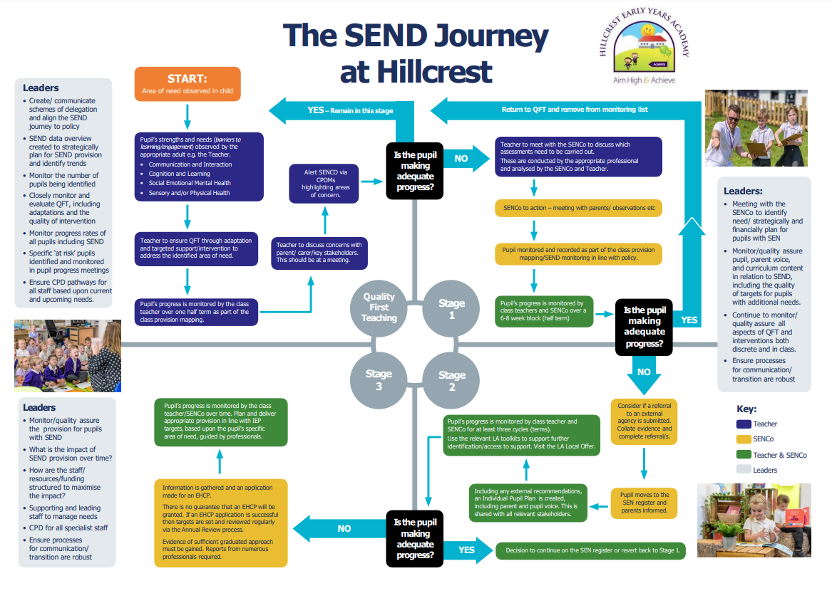

The local authority local offer
Our contribution to the local offer is: https://www.hillcrestearlyyearsacademy.co.uk/early- years/parents/special-educational-needs/
Our local authority’s local offer is published here: https://www.lincolnshire.gov.uk/childcare-and- family-support/special-educational-needs-and-disabilities/send-local-offer/

Monitoring arrangements
This policy and information report will be reviewed by the SENDCo and the SEND Trustee and presented to the Board of Trustees every year. It will also be updated if any changes to the information are made during the year.
It will be approved by the Board of Trustees and then shared with the Board of Trustees and Members and staff.

Links with other policies and documents
This policy links to our policies on:
- Accessibility plan
- Behaviour Policy
- SEND Information Report
- Anti-Bulling Policy
- Child Protection and Safeguarding Policy
- Equality Policy

