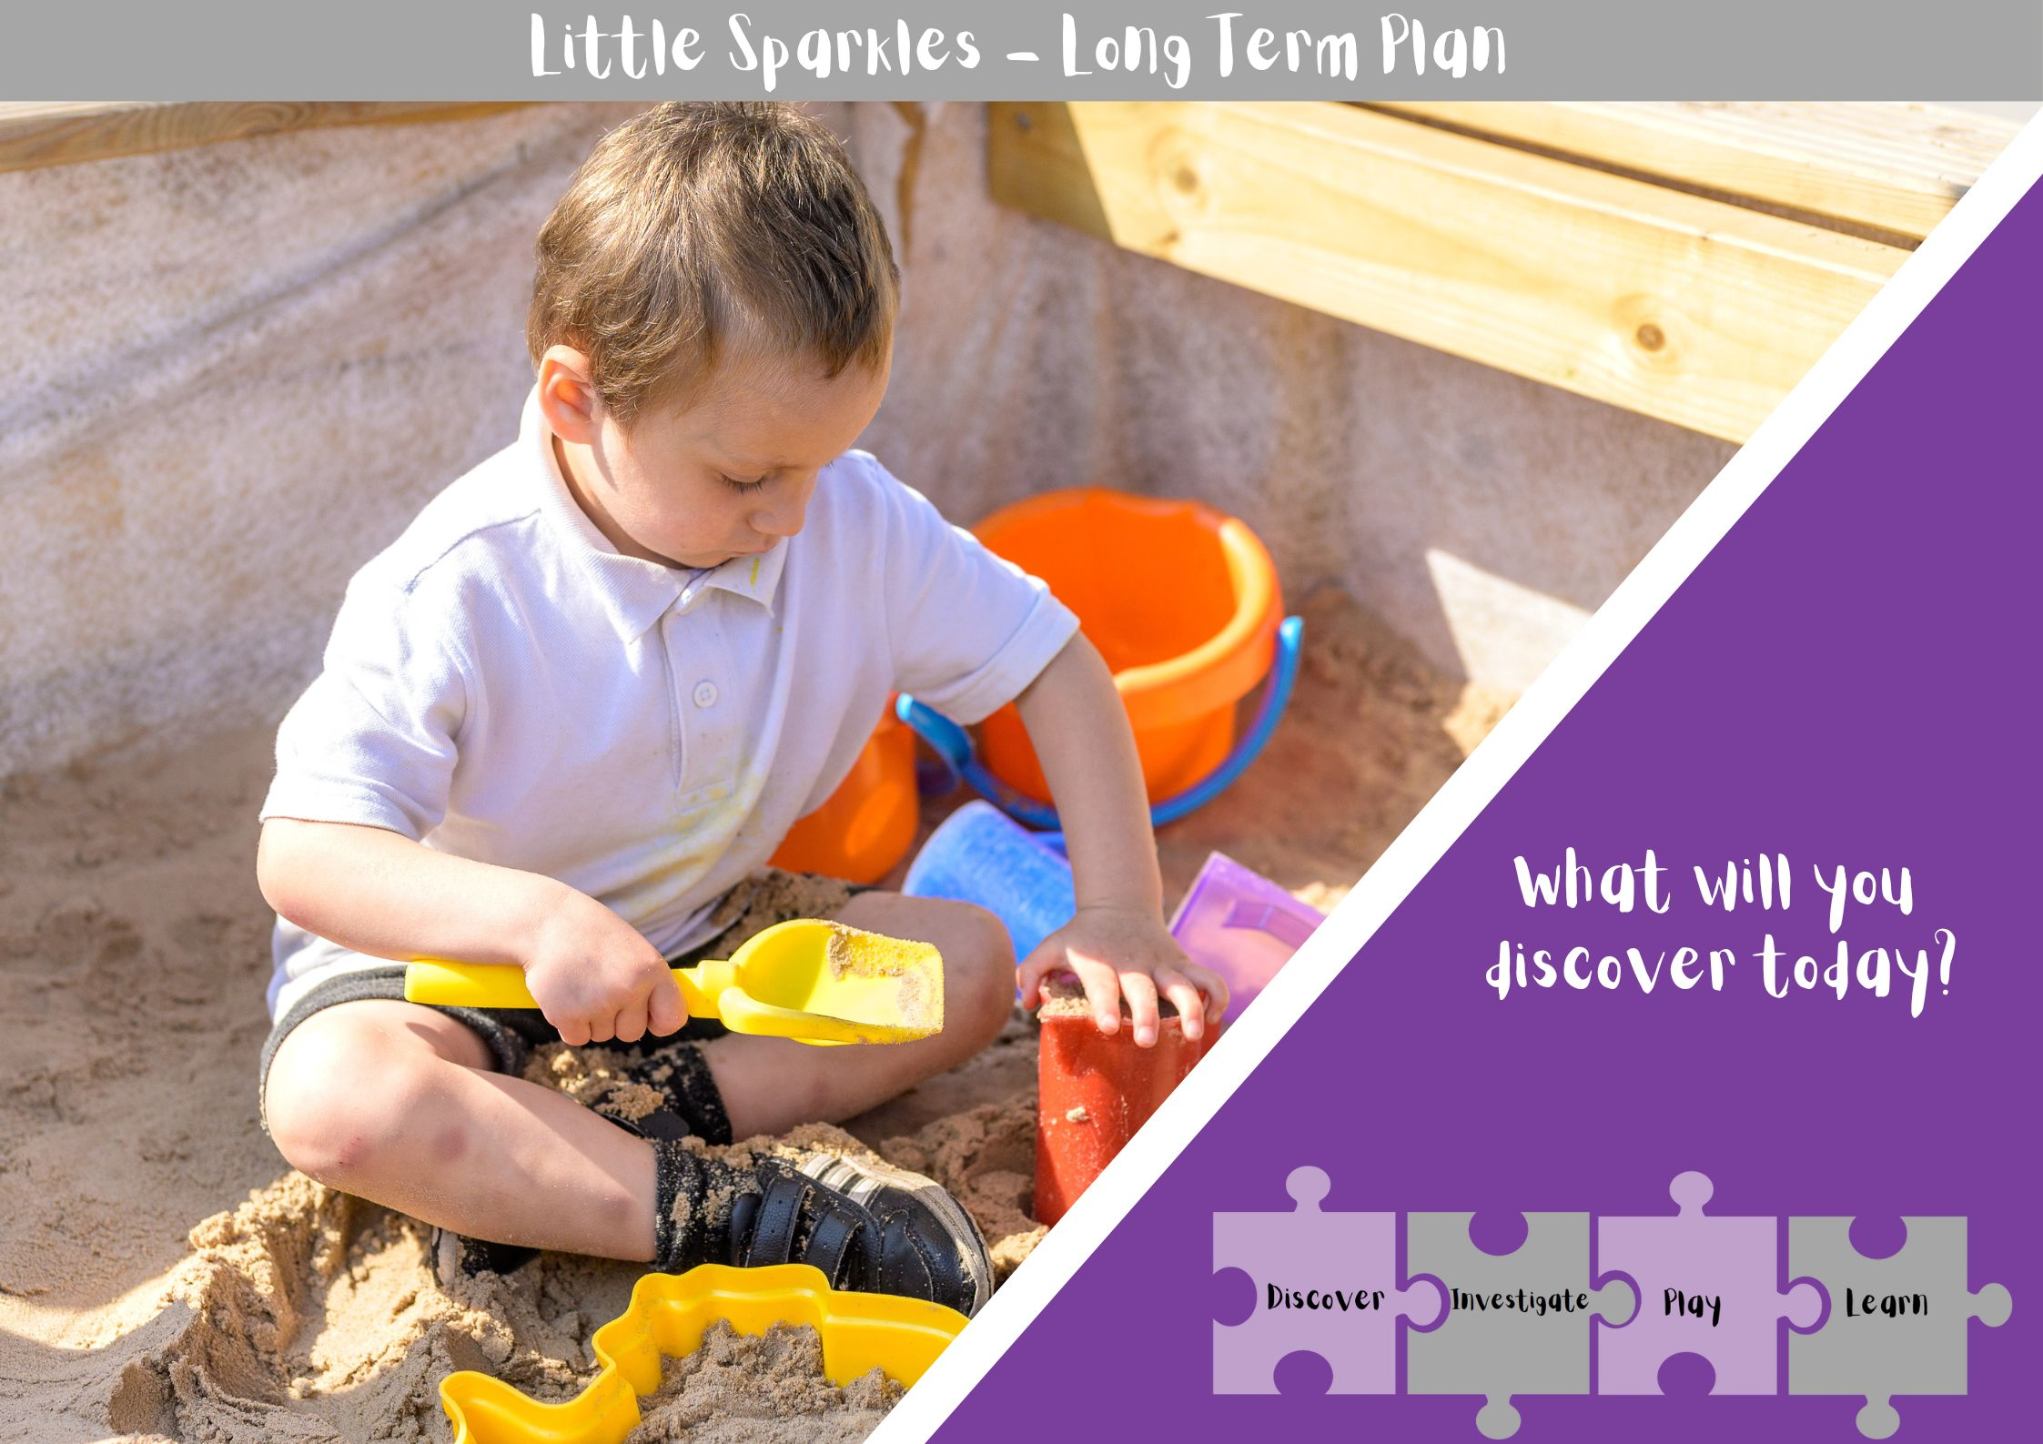
Half Term | Week 1 | Week 2 | Week 3 | Week 4 | Week 5 | Week 6 | Week 7 | Week 8
A1 | All about me  Settling in  Baseline  Routines
A2 | Halloween  Ten Timid Ghosts-Jennifer O Connell | On the farm-Axel Scheffler | The gingerbread man |  | Christmas song practice |  | Christmas
S1 | The Ugly duckling |  | The Gruffalo |  | We’re going on a bear hunt
S2 | Tiddler the fish |  | Guess how much I love you |  | Easter
S1 | Ketchup on your cornflakes |  | Little red riding hood |  | Dear zoo
S2 | Jack and the beanstalk |  | Goldilocks and the 3 bears |  | The hungry caterpillar | The 3 billy goats gruff | Last week fun

Half Term | Nursery Rhyme focus
Autumn 1 | - Twinkle Twinkl Little star  - Baa Baa Black sheep (rainbow sheep)
Autumn 2 | - I’m a little tea pot  - Three blind mice
Spring 1 | - Old MacDonald had a farm  - 5 Little ducks
Spring 2 | - Wind the bobbin up  - 5 little men in a flying saucer
Summer 1 | - Itsy Bitsy spider  - 5 little monkeys jumping on the bed
Summer 2 | - The wheels on the bus  - Row Row Row your boat

Little Sparkles is the first step to learning at Hillcrest Early Years Academy. This is our 2-3 year old room and supports children’s first step into their educational life.
In Little Sparkles, we use our skills progression document to inform our enhancements throughout the environment and give our children a ‘Window into the world’ through carefully chosen books.
Enhancements are created by our highly skilled and imaginative staff and the enhancements follow our Long-Term Plan. Our enhancements are also based on the children’s interests. Our adults observe the children’s interests and fascinations and plan enhancements to suit the needs of individual children and the group. We use the observation, interaction, reflection, planning and response model to inform weekly planning.
Our Continuous provision is planned to follow our bespoke curriculum and we consult the early excellence guide to continuous provision.
We have a free flow from indoor to outdoor discovery time to give our children the chance to independently explore their environment and feel safe throughout their time at nursery.
Our highly skilled adults are trained to deliver and incorporate Quality Interactions within the environment using the SHREC approach.
Our well-planned learning environment offers uninterrupted time for children to follow their own ideas and interests.
We have low starting points with our communication and language, so we ensure we have a language rich environment and high quality interactions during discovery time so children feel safe to learn and this stimulates early language development, a school development priority for next year (2024/25).

Continuous provision areas

- Water Resource Collection 2-3yrs
- Wet Sand Resource Collection 2-3yrs
- Dry Sand Resource Collection 2-3yrs
- Dough Resource Collection 2-3yrs
- Science Resource Collection 2-3yrs
- Maths Resource Collection 2-3yrs
- Mark Making Resource Collection 2-3yrs
- Books & Puppets Resource Collection 2-3yrs
- Small World Resource Collection 2-3yrs
- Small Block Resource Collection 2-3yrs
- Large Block Resource Collection 2-3yrs
- Small Construction Resource Collection 2-3yrs
- Domestic Role Play Resource Collection 2-3yrs

