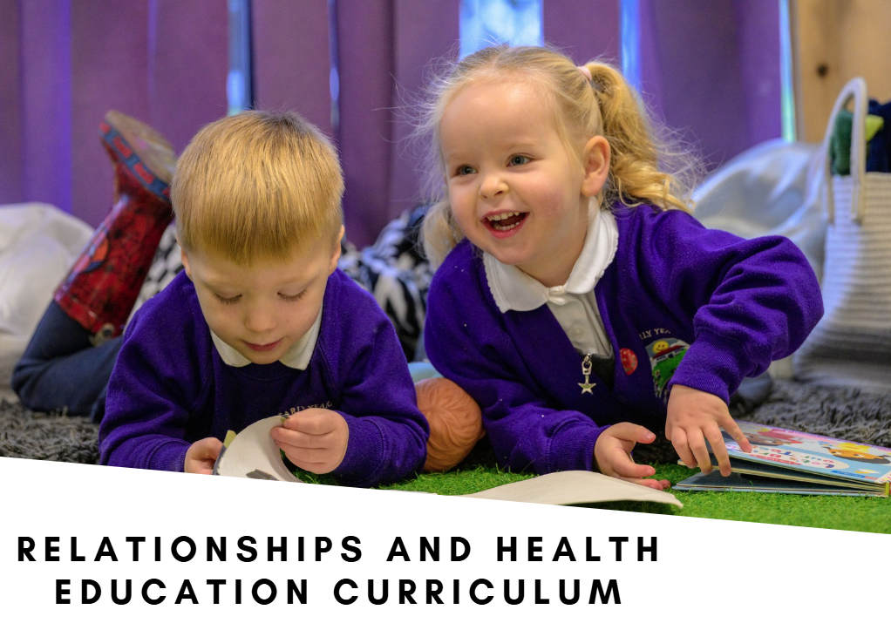

At Hillcrest Early Years Academy, our Relationships and Health Education (RHE) curriculum is designed to help every child develop the knowledge, understanding, confidence and character needed to lead safe, healthy and happy lives. Through a carefully sequenced curriculum from Nursery to Year 2, children learn how to understand themselves, build positive relationships, manage emotions, celebrate differences and make safe choices.

We recognise that strong relationships are at the heart of learning and wellbeing. Our curriculum enables children to develop a secure sense of self, understand their place within their family, school and wider community, and appreciate that every individual is unique and valued. Through explicit teaching, discussion, reflection and real-life experiences, children learn to communicate effectively, show empathy, resolve conflict respectfully and develop positive friendships.

Children are taught the importance of physical, emotional and online safety through age-appropriate learning about trusted adults, personal boundaries, feelings, safe and unsafe situations, keeping healthy and seeking help when needed. We want every child to know that their voice matters, that they have the right to feel safe, and that there are always trusted people who will listen and support them.

The curriculum is underpinned by our MAGIC Values:

Memories – creating meaningful experiences and relationships that help children understand themselves, their families, their communities and the world around them.

Ambitious Aspirations – encouraging children to dream big, believe in themselves, persevere through challenges and recognise their potential.

Growth – developing emotional resilience, self-awareness and a positive mindset that embraces learning, change and personal development.

Independence – enabling children to make responsible choices, manage their wellbeing, express their views confidently and become active participants in their own learning and safety.

Courage – empowering children to speak up, seek help when needed, stand up for themselves and others, and make the right choices even when situations are challenging.

Through the six progressive themes of Being Me in My World, Celebrating Difference, Dreams and Goals, Healthy Me, Relationships and Changing Me, children develop the knowledge and life skills needed to flourish both now and in the future. They learn that healthy relationships are built on kindness, trust and respect; that differences should be celebrated; that everyone has rights and responsibilities; and that making mistakes, facing challenges and experiencing change are all part of growing up.

Ultimately, our ambition is for every child to leave Hillcrest as a confident, resilient and caring young person who understands how to keep themselves safe, build positive relationships, contribute positively to their community and live out our MAGIC values every day.

Termly overview
Term | Autumn Term 1 | Autumn Term 2 | Spring Term 1 | Spring term 2 | Sumer Term 1 | Summer Term 2
Puzzle | Being me in my World | Celebrating Difference | Dreams and Goals | Healthy Me | Relationships | Changing Me
Focus | Who am I and how do I fit? | Respect for similarity and difference. Anti-bullying and being unique. | Aspirations – how to achieve goals and understanding the emotions that go with this. | Being and keeping safe and healthy. | Building positive, healthy relationships. | Coping positively with change.
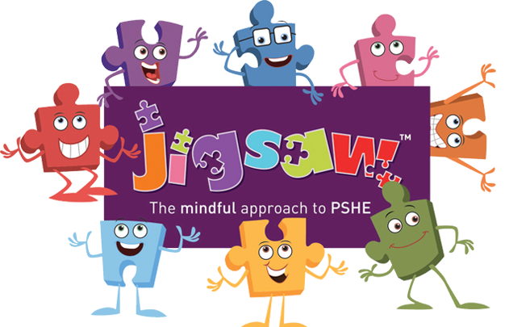

Little Gems (3-4 Years)
Being me in my World | Celebrating Difference | Dreams and Goals | Healthy Me | Relationships | Changing Me
Who... Me?!  I understand how it feels to belong and that we are similar and different | What am I good at?  I know how it feels to be proud of something I am good at | Challenge  I understand what a challenge means | Everybody's Body  I know the names for some parts of my body and am starting to understand that I need to be active to be healthy | My Family and Me!  I can tell you about my family | My Body  I can name parts of my body and show respect for myself
How am I feeling today?  I understand how feeling happy and sad can be expressed | I’m Special, I’m Me!  I can tell you one way I am special and unique | Never Giving Up  I can keep trying until I can do something | We like to move it, move it!  I can tell you some of the things I need to do to be healthy | Make friends, make friends, never ever break friends Part 1  I understand how to make friends if I feel lonely | Respecting My Body  I can tell you some things I can do and some food I can eat to be healthy
Being at Nursery/Pre-school  I can work together and consider other people’s feelings | Families  I know that all families are different | Setting a Goal  I can set a goal and work towards it | Food Glorious Food  I know what the word ‘healthy’ means and that some foods are healthier than others | Make friends, make friends, never ever break friends Part 2  I can tell you some of the things I like about my friends | Growing Up  I understand that we all start as babies and grow into children and then adults
Gentle hands  I can use gentle hands and understand that it is good to be kind to people | Homes  I know there are lots of different homes | Obstacles and Support  I know some kind words which can encourage people | Sweet Dreams  I know how to help myself go to sleep and that sleep is good for me | Falling Out and Bullying Part 1  I know what to say and do if somebody is mean to me | Growth and Change  I know that I grow and change
Our Rights  I am starting to understand children’s rights and this means we should all be allowed to learn and play | Making friends  I can tell you how I could make new friends | Flight to the Future  I can start to think about the jobs I might like to do when I’m older | Keeping Clean  I can wash my hands and know it is important to do this before I eat and after I go to the toilet | Falling Out and Bullying Part 2  I can manage my feelings | Fun and Fears  I can talk about how I feel moving to School from Nursery
Our responsibilities  I am learning what being responsible means | Standing up for Yourself  I can use my words to stand up for myself | Footprint Awards  I can feel proud when I achieve a goal | Safe Adult  I know who my safe adults are and how to stay safe if they are not close by me | Being the best friends we can be  I can work together and enjoy being with my friends | Celebration  I can remember some fun things about Nursery this year

Reception (4-5 Years)
Being me in my World | Celebrating Difference | Dreams and Goals | Healthy Me | Relationships | Changing Me
Who... Me?!  I understand how it feels to belong and that we are similar and different | What am I good at?  I can identify something I am good at and understand everyone is good at different things | Challenge  I understand that if I persevere I can tackle challenges | Everybody's Body  I understand that I need to exercise to keep my body healthy | My Family and Me!  I can identify some of the jobs I do in my family and how I feel like I belong | My Body  I can name parts of the body
How am I feeling today?  I can start to recognise and manage my feelings | I’m Special, I’m Me!  I understand that being different makes us all special | Never Giving Up  I can tell you about a time I didn’t give up until I achieved my goal | We like to move it, move it!  I understand how moving and resting are good for my body | Make friends, make friends, never ever break friends Part 1  I know how to make friends to stop myself from feeling lonely | Respecting My Body  I can tell you some things I can do and foods I can eat to be healthy
Being at School  I enjoy working with others to make school a good place to be | Families  I know we are all different but the same in some ways | Setting a Goal  I can set a goal and work towards it | Food Glorious Food  I know which foods are healthy and not so healthy and can make healthy eating choices | Make friends, make friends, never ever break friends Part 2  I can think of ways to solve problems and stay friends | Growing Up  I understand that we all grow from babies to adults
Gentle hands  I understand why it is good to be kind and use gentle hands | Homes  I can tell you why I think my home is special to me | Obstacles and Support  I can use kind words to encourage people | Sweet Dreams  I know how to help myself go to sleep and understand why sleep is good for me | Falling Out and Bullying Part 1  I am starting to understand the impact of unkind words | Fun and Fears Part 1  I can express how I feel about moving to Year 1
Our Rights  I am starting to understand children’s rights and this means we should all be allowed to learn and play | Making friends  I can tell you how to be a kind friend | Flight to the Future  I understand the link between what I learn now and the job I might like to do when I’m older | Keeping Clean  I can wash my hands thoroughly and understand why this is important especially before I eat and after I go to the toilet | Falling Out and Bullying Part 2  I can manage my feelings | Fun and Fears Part 2  I can talk about my worries and/or the things I am looking forward to about being in Year 1
Our responsibilities  I am learning what being responsible means | Standing up for Yourself  I know which words to use to stand up for myself when someone says or does something unkind | Footprint Awards  I can say how I feel when I achieve a goal and know what it means to feel proud | Safe Adult  I know who my safe adults are and how to stay safe if they are not close by me | Being the best friends we can be  I know how to be a good friend | Celebration  I can share my memories of the best bits of this year in Reception

Year 1 (5-6 Years) Black – PSHE Learning Intention Purple – Social and Emotional Development Learning Intention
Being me in my World | Celebrating Difference | Dreams and Goals | Healthy Me | Relationships | Changing Me
Special and Safe  I know that I am special.  I know that I belong in my class.  I can talk about what helps me feel safe at school.  I feel special and safe in my class | The same as...  I can identify similarities between people in my class  I can tell you some ways in which I am the same as my friends | My Treasure Chest of Success  I can set simple goals  I can tell you about a thing I do well | Being Healthy  I understand the difference between being healthy and less healthy, and know some ways to keep myself healthy  I feel good about myself when I make healthy choices | Families  I can identify the members of my family and understand that there are lots of different types of families  I know how it feels to belong to a family and care about the people who are important to me | Life Cycles  I am starting to understand the life cycles of animals and humans  I understand that changes happen as we grow and that this is OK
My Class  I understand the rights and responsibilities as a member of my class  I know that I belong to my class | Different from...  I can identify differences between people in my class  I can tell you some ways I am different from my friends | Steps to Goals  I can set a goal and work out how to achieve it  I can tell you how I learn best | Healthy Choices  I know how to make healthy lifestyle choices  I feel good about myself when I make healthy choices | Making Friends  I can identify what being a good friend means to me  I know how to make a new friend | Changing Me  I can tell you some things about me that have changed and some things about me that have stayed the same  I know that changes are OK and that sometimes they will happen whether I want them to or not
Rights and Responsibilities  I understand the rights and responsibilities for being a member of my class  I know how to make my class a safe place for everybody to learn | What is ‘bullying’?  I can tell you what bullying is  I understand how being bullied might feel | Achieving Together  I understand how to work well with a partner  I can celebrate achievement with my partner | Clean and Healthy  I know how to keep myself clean and healthy, and understand how germs cause disease/illness  I know that all household products including medicines can be harmful if not used properly  I am special so I keep myself safe | Greetings  I know appropriate ways of physical contact to greet my friends and know which ways I prefer  I can recognise which forms of physical contact are acceptable and unacceptable to me | My Changing Body  I can tell you how my body has changed since I was a baby  I understand that growing up is natural and that everybody grows at different rates
Rewards and Feeling Proud  I know my views are valued  I recognise how it feels to be proud of an achievement | What do I do about bullying?  I know some people who I could talk to if I was feeling unhappy or being bullied  I can be kind to children who are bullied | Stretchy Learning  I can tackle a new challenge and understand this might stretch my learning  I can tell you how I feel when I am faced with a new challenge | Medicine Safety  I understand that medicines can help me if I feel poorly and I know how to use them safely  I know some ways to help myself when I feel poorly | People who help us  I know who can help me in my school community  I know when I need help and know how to ask for it | Boys’ and Girls’ Bodies  I can identify the parts of the body that make boys different to girls and can use the correct names for private body parts: penis, testicles, vulva, anus  I respect my body and understand which parts are private
Consequences  I can recognise  the choices I make and understand the consequences  I recognise the range of feelings when I face certain consequences | Making new friends  I know how to make new friends  I know how it feels to make a new friend | Overcoming Obstacles  I can tell you about obstacles which make it more difficult to achieve my new challenge and have ideas to overcome them  I can explain how I feel when I face obstacles and how I feel when I overcome them | Road Safety  I know how to keep safe when crossing the road, and about people who can help me to stay safe  I can recognise when I feel frightened and know who to ask for help | Being My Own Best Friend  I can recognise my qualities as a person and a friend  I know ways to praise myself | Learning and Growing  I understand that every time I learn something new I change a little bit  I enjoy learning new things
My Inner Cheerleader  I understand my rights and responsibilities and how I am in control of the choices I make  I understand my choices | Celebrating difference; celebrating me  I can tell you some ways I am different from my friends  I understand these differences make us all special and unique | Celebrating My Success  I can tell you how I felt when I succeeded in a new challenge and how I celebrated it  I know how to store the feelings of success in my internal treasure chest | Happy, Healthy Me  I can tell you why I think my body is amazing and can identify some ways to keep it safe and healthy  I can recognise how being healthy helps me to feel happy | Celebrating My Special Relationships  I can tell you why I appreciate someone who is special to me  I can express how I feel about them | Coping with Changes  I can tell you about changes that have happened in my life  I know some ways to cope with changes

Year 2 (6-7 Years) Black – PSHE Learning Intention Purple – Social and Emotional Development Learning Intention
Being me in my World | Celebrating Difference | Dreams and Goals | Healthy Me | Relationships | Changing Me
Hopes and Fears for the Year  I can identify some of my hopes and fears for this year.  I can recognise when I feel worried and know who to ask for help | Assumptions  I am starting to understand that sometimes people make assumptions about boys and girls (stereotypes)  I understand some ways in which boys and girls are similar and feel good about this | Goals to Success  I can choose a realistic goal and think about how to achieve it  I can tell you things I have achieved and say how that makes me feel | Healthy Eating  I can sort foods into the correct food groups and know which foods my body needs every day to keep me healthy  I have a healthy relationship with food and know which foods I enjoy the most | Families  I can identify the different members of my family, understand my relationship with each of them and know why it is important to share and cooperate  I accept that everyone’s family is different and understand that most people value their family | Life Cycles in Nature  I can recognise cycles of life in nature  I understand there are some changes that are outside my control and can recognise how I feel about this
Rights and Responsibilities  I understand the rights and responsibilities for being a member of my class and  school, and the importance of making contributions  I know how to help myself and others feel like we belong | Stereotypes  I am starting to understand that sometimes people make assumptions about boys and girls (stereotypes)  I understand some ways in which boys and girls are different and accept that this is OK | Being Healthy  I know what I need to keep myself healthy  I am motivated to make healthy choices that help me to reach my goals | Healthy Eating  I can make some healthy snacks and explain why they are good for my body  I can express how it feels to share healthy food with my friends | Keeping Safe - exploring physical contact  I understand that there are lots of forms of physical contact within a family and that some of this is acceptable and some is not  I know which types of physical contact I like and don’t like and can talk about this | Growing from Young to Old  I can tell you about the natural process of growing from young to old and understand that this is not in my control  I can identify people I respect who are older than me
Rewards and Feeling Proud  I know my views are valued and I can contribute my own ideas about rewards  I recognise how it feels to be proud of an achievement | Why does bullying happen?  I understand that bullying is sometimes about difference  I can tell you how someone who is bullied feels  I can be kind to children who are bullied | Learning with Others  I can recognise who I work well with and who it is more difficult for me to work with  I can tell you how working with other people helps me learn | Keeping Safe at Home  I can recognise hazards in my home, including fire risks and hot things, and know how to reduce risks and keep myself safe  I can recognise when I feel worried or unsafe and know to tell an adult straight away | Friends and Conflict  I can identify some of the things that cause conflict with my friends  I can demonstrate how to use the positive problem-solving technique to resolve conflicts with my friends | The Changing Me  I can recognise how my body has changed since I was a baby and where I am on the continuum from young to old  I feel proud about becoming more independent
Consequences  I can recognise the choices I make and understand the consequences and I can contribute my own ideas about what actions may lead to consequences  I can help make my class a safe and fair place | Standing up for myself and others  I can recognise what is right and wrong and know how to look after myself  I know when and how to stand up for myself and others  I know how to get help if I am being bullied | A Group Challenge  I can work well in a group to create an end product  I can work with other people in a group to solve problems | Safe Outside  I can recognise risks and know how to keep safe around roads, railways, and water, and can explain why safety rules help protect me  I can recognise some of the feelings I get when something feels unsafe and know some ways to manage these to make a safer choice | Secrets  I understand that sometimes it is good to keep a secret and sometimes it is not good to keep a secret  I know how it feels to be asked to keep a secret I do not want to keep and know who to talk to about this | Boys’ and Girls’ Bodies  I can recognise the physical differences between boys and girls, use the correct names for parts of the body (penis, testicles, vulva, vagina, anus) and appreciate that some parts of my body are private  I can describe what I enjoy about being a boy or girl whilst understanding we are all different
Responsibilities  I understand how following my responsibilities and using my Inner Cheerleader will help me and others learn  I work co-operatively | We're All Different  I understand that it is OK to be different from other people and to be friends with them  I understand we shouldn’t judge people if they are different  I know how it feels to be a friend and have a friend | Being Relaxed  I can show or tell you what relaxed means and I know some things that make me feel relaxed and some that make me feel stressed  I can tell you when a feeling is weak and when a feeling is strong | Medicine Safety  I understand how medicines work in my body and how important it is to use them safely  I feel positive about caring for my body and keeping it healthy | Trust and Appreciation  I recognise and appreciate people who can help me in my family, my school and my community  I understand how it feels to trust someone | Assertiveness  I understand there are different types of touch and can tell you which ones I like and don’t like  I am confident to say what I like and don’t like and can ask for help
Owning our Learning Charter  I recognise the choices I make and understand the consequences  I can follow the Learning Charter | Celebrating difference and still being friends  I can tell you some ways I am different from my friends  I understand these differences make us all special and unique | Celebrating Our Achievement  I know how to share success with other people  I know how contributing to the success of a group feels and I am able to store those feelings in my internal treasure chest (proud) | Happy, Healthy Me!  I can explain how to keep my body healthy and safe at home and when I'm out  I can make good choices that help me stay healthy and safe | Celebrating My Special Relationships  I can express my appreciation for the people in my special relationships  I am comfortable accepting appreciation from others | Looking Ahead  I can identify what I am looking forward to when I move to my next class  I can start to think about changes I will make when I am in my next class and know how to go about this

