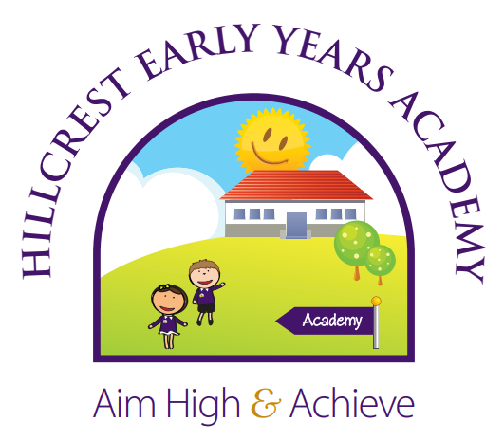

RE Curriculum
EYFS, Year 1 and 2

Intent | At Hillcrest Early Years Academy, the aim of Religious Education is to help children to acquire and develop knowledge and understanding of Christianity and the other principal religions represented in Great Britain; to appreciate the way that religious beliefs shape life and our behaviour, develop the ability to make reasoned and informed judgements about religious and moral issues and enhance their spiritual, moral, social and cultural development.  Religious Education is taught throughout the school in such a way as to reflect the overall aims, values, and philosophy of the school. At Hillcrest Early Years Academy, Religious Education plays an important role, along with all other curriculum areas, particularly PSHE, in promoting the spiritual, moral, social, and cultural development of our children.
Implementation | At Hillcrest Early Years Academy, it has been agreed that having taken into account the requirements and guidelines presented in the Lincolnshire Agreed Syllabus, the following religions have been selected for study:  - Christianity  - Islam  - Hinduism  As Christianity is the predominant religion in the school's pupil population and in the community surrounding the school, Christianity is the chosen faith for Progressed Study.  There are no presumptions made as to the religious backgrounds and beliefs and values of the children and the staff. We value the religious background of all members of the school community and hope that this will encourage individuals to share their own experiences with others freely. All religions and their communities are treated with respect and sensitivity and we value the links, which are, and can be made between home, school, and a faith community. We acknowledge that each religion studied can contribute to the education of all our pupils. We promote teaching in Religious Education that stresses open enquiry and first-hand experiences wherever possible for both staff and children.
Impact | The children at Hillcrest Early Years Academy enjoy learning about diverse religions and why people choose or choose not to follow a religion. Through their R.E. learning, the children can make links between their own lives and those of others in their community and in the wider world. R.E. acts as a hub, therefore, between social aspects of learning, science and geography. Through R.E. our children are developing an understanding of other people’s cultures and ways of life, which they are then able to communicate to the wider community.  R.E. offers our children the means by which to understand how other people choose to live and to understand why they choose to live in that way. As such, R.E. is invaluable in an ever changing world.

EYFS Understanding the World | Development Matters 2020 Statements  Pupils should be taught to: | Coverage
Birth to Three | Make connections between the feature of their family and other families.  Notice differences between people. | RE is explored though topics covered in long term planning. RE is explored through different EYFS areas and integrated into different parts of their curriculum and there are strong links to different celebrations e.g. birthdays, Christmas and other religious celebrations. Whilst specific religions are not taught discretely, children are given the opportunities to explore and develop tolerance and understanding for different religions through topic based teaching.  These skills will be taught over the year in the following topics:  - Marvellous Me  - Celebrations (e.g. Diwali, Easter, Christmas, Chinese new year)
Three and Four Year Olds | Continue developing positive attitudes about the differences between people.  Know that there are different countries in the world and talk about the differences they have experienced or seen in photos.
Reception | Understand that some places are special to members of their community  Recognise that people have different beliefs and celebrate special times in different ways.
Early Learning Goals | Talk about the lives of the people around them and their roles in society.  Know some similarities and differences between different religious and cultural communities in this country, drawing on their experiences and what has been read in class.

Year 1 | Christianity  Unit - God  What do Christians learn/understand about God through Old Testament Bible stories? What do stories in the New Testament tell Christians about Jesus | Christianity  Unit – Being Human  What does the Bible say about how Christians should treat others/live their lives? How can Christian faith and beliefs be seen in the actions of inspirational Christians? | Islam  Unit - God  What do people believe about God? How is Allah described in the Qur’an? What do Muslims learn about Allah and their faith through the Qur’an? | Islam  Unit – Being Human  How does faith and belief affect the way people live their lives? What does the Qur’an say about how Muslims should treat others and live their lives? How can Muslim faith and beliefs be seen in the actions of inspirational Muslims? | Hinduism  Optional Unit | Hinduism  Optional Unit
Year 2 | Christianity  Unit – Community, worship and celebration  What do Christians do to express their beliefs? Which celebrations are important to Christians? | Christianity  Unit – Life Journey  What do Christians do to celebrate birth? What does it mean and why does it matter to belong? | Islam  Unit – Community, worship and celebration  How do people express their religion and belief? What do Muslims do to express their beliefs? Which celebrations are important to Muslims? | Islam  Unit – Life Journey  Rites of passage: How do people mark important events in life? What do Muslims do to celebrate birth? | Hinduism  Optional Unit | Hinduism  Optional Unit
KS1 Long Term Plan

Progression of Knowledge and Skills
Knowledge and Skill | EYFS | Year 1 | Year 2
Beliefs, Teachings, Sources of Wisdom & Authority | - Talk about a religious story. | - Retell a religious (e.g., Christian, Islam etc) story and talk about it | Retell a religious story and suggest meanings to some religious and moral stories
Ways of Living | - Talk about some belonging ceremonies. (e.g., Christening) | - Recall and name different beliefs and practices, including festival, worship rituals and ways of life | - Ask and respond to questions about why religious communities do different things
Ways of Expressing Meaning | - Talk about a religious symbol. (e.g., star at Christmas) | Recognise religious art, symbols and words and talk about them | Recognise that religious symbols, words, and actions express a community way of living
Questions of Identity, Diversity and Belonging | - Talk about their family | Begin to ask questions about the faith communities in their school | - Notice and respond sensitively to some similarities between different religious and worldviews
Questions of Meaning, Purpose and Truth | - Say how they feel when they are happy or sad. | - Think about the special things that happen to them and others. | - Explore questions about meaning and truth. - Discuss sacred writings and sources of wisdom
Questions of Values and Commitments | - Say why their family is important to them. | - Think about what is important to them and to other people | - Begin to express their ideas and opinions and to recognise there could be more than one answer

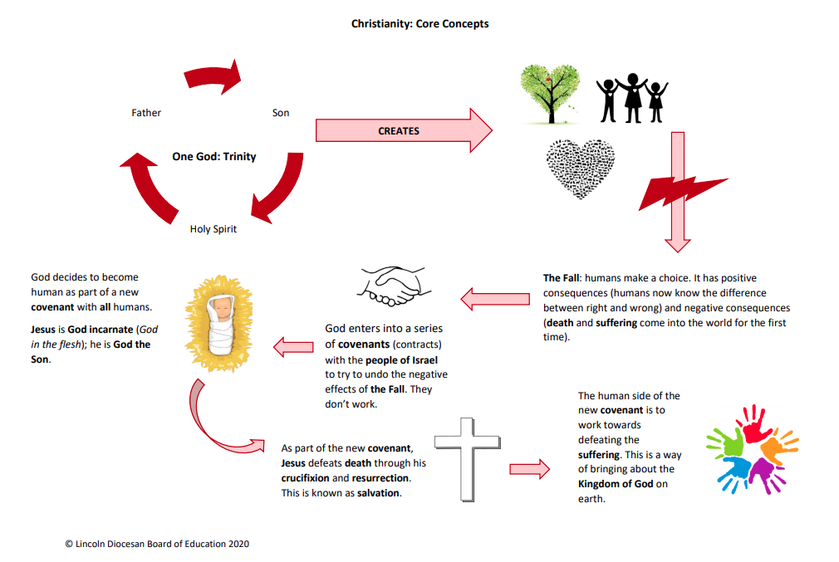
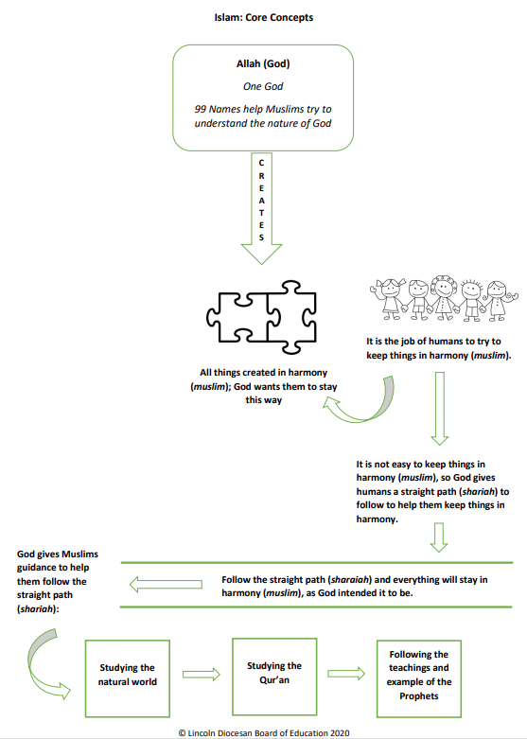
Concept Maps
Hinduism: Core Concepts
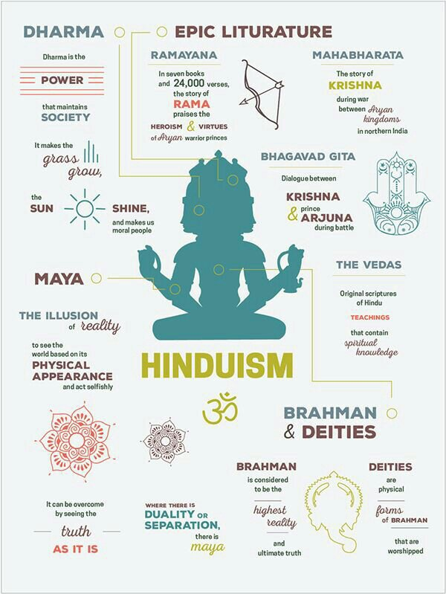

RE Vocabulary – Early Years
family, mum, dad, brother, sister, grandma, grandad, Christmas, Jesus, friends, uncle, auntie, cousin, community, belonging, different, same, festival.

RE Vocabulary – Year 1
family, mum, dad, brother, sister, grandma, grandad, Christmas, Jesus, friends, uncle, auntie, cousin, community, belonging, different, same, festival, prayer, Christian, Christianity, Holy Bible, faith, belief, church, parable, cross, Old Testament, New Testament, prayer, Nativity, resurrection, crucifixion, miracle, forgiveness, commandments, Islam, Muslim, Mosque, Qur’an, Mohammed, Imam, Hindu, Hinduism, God, Goddess, Shrine, Mandir, Vedas,

RE Vocabulary – Year 2
family, mum, dad, brother, sister, grandma, grandad, Christmas, Jesus, friends, uncle, auntie, cousin, community, belonging, different, same, Christian, Christianity, beliefs and practices. values of others. · See the world through the eyes of others. argument. Holy Bible, faith, belief, church, parable, cross, Old Testament, New Testament, Baptism, Lent, marriage, Easter, Advent, Christening, marriage, alter, vicar, worship, Nativity, resurrection, crucifixion, miracle, forgiveness, commandments, Islam, Muslim, Mosque, Qur’an, Allah, Mohammed, Imam, Pilgrimage, Mecca, Shahadah, Salah, Sawm, Zakah, Hajj, fasting, charity, Eid, Ramadan, Hindu, Hinduism, God, Goddess, Shrine, Mandir, Vedas, Brahman, Deity, birth rites, meditation, karma, reincarnation, Diwali, Holi, cremation, India, River Ganges.

