

Computing Curriculum
EYFS, Year 1 and 2

Intent | At Hillcrest Early Years Academy, we recognise that children are living within an increasingly technological world, and we aim to develop confidence, knowledge, and skills in this area. Our intent is for our Curriculum to be based upon experiential, memorable learning which is inclusive for all children. Computing skills are taught specifically during computing sessions in Year 2 and through continuous provision in Year 1. Skills are practiced and then applied across the curriculum to enhance other subjects. Alongside computing skills, we regularly revisit knowledge. For example, online safety and the importance of why we need to keep ourselves safe on the internet. As children leave our academy, we aim for children to transfer this knowledge and have the confidence to implement these skills in everyday situations.
Implementation | Each class has access to a range of technology from iPads and laptops to programmable robots. Teaching is delivered using this technology. Although the EYFS Framework no longer has a focus on technology, we have written a bespoke Curriculum which incorporates technology into the Early Years, as we feel it is vitally important for our children to understand how to use technology appropriately. This is delivered through the continuous provision.  In Key Stage 1, the children will learn in fun and engaging ways and be encouraged to have the confidence to experiment with a range of technology. Learning is made memorable to children through links with other areas of the curriculum, therefore making learning relevant. Children learn to understand what algorithms are; how they are implemented as programs on digital devices; and that programs work by following precise and unambiguous instructions. They will be taught to create and debug simple programs and use logical reasoning to predict the behaviour of simple programs. They will be shown how to use a range of technology purposefully to create, organise, store, manipulate and retrieve digital content as well as recognise common uses of information technology beyond school. They will be taught to use technology safely and respectfully, keeping personal information private; identify where to go for help and support when they have concerns about content or contact on the internet or other online technologies. Each of these skills will be taught through exciting, themed units. Knowledge and skills are sequential and progressive to ensure that children know and remember more; learning is revisited in a cyclical process.
Impact | After the implementation of this robust computing curriculum, children at Hillcrest Early Years Academy will be digitally literate and able to join the rest of the world on its digital platform. They will be equipped, not only with the skills and knowledge to use technology effectively and for their own benefit, but more importantly – safely. The biggest impact we want for our children is that they understand the consequences of using the internet and that they are also aware of how to keep themselves safe online.  As children become more confident in their abilities in Computing, they will become more independent with key life skills such as problem-solving, logical thinking and self-evaluation. They will have the ‘courage’ to have a go and will have created lasting memories which will prepare them for the next stage of their education journey.

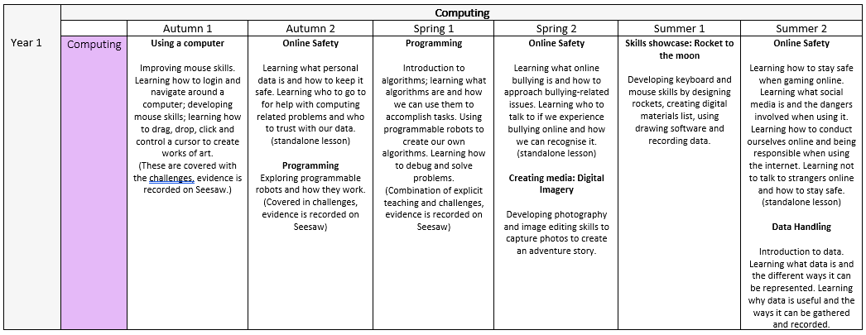
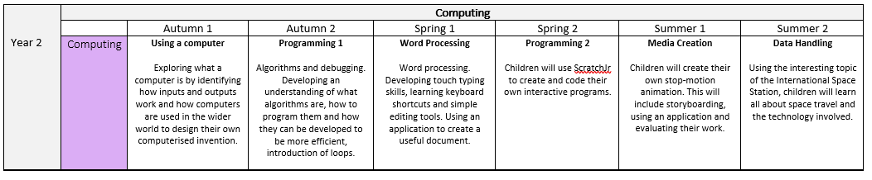
Computing Long Term Plan
 | Year 1 | Year 2
Autumn Term | USING A COMPUTER:  Understanding what a computer is and how to use one.  Logging in.  Click and drag skills.  Opening and using software. | USING A COMPUTER:  Understanding the different parts of a computer.  Understanding the application of technology.  Using a computer to design their own inventions.  PROGRAMMING:  To understand what machine learning is and how that enables computers to make predictions. To know that loops in programming are where you set a certain instruction (or instructions) to be repeated multiple times.
Autumn Term | ONLINE SAFETY 1:  Understanding what personal information is.  Understanding who we should and should not share our information with.  Understanding what passwords are and what makes a good one. | ONLINE SAFETY 1:  Recapping what personal information is.  Recapping who we should and should not share our information with.  Recapping what passwords are and what makes a good one.
Spring Term | PROGRAMMING  Understanding what algorithms are.  Understanding how we can use programmable robots to create algorithms.  Learning how to problem solve and debug mistakes. | WORD PROCESSING:  Understanding that computers can be used to create useful documents.  Learning how to touch-type.  Learning how to create and edit documents.  Learning how to add images to illustrate documents.  PROGRAMMING:  Recapping what algorithms are.  Using ScratchJr to create programs using coding blocks.  Applying our knowledge to create a bespoke program.
Spring Term | ONLINE SAFETY 2:  Understanding what online bullying is.  Understanding what to do and who to talk to if we are bullied or harassed online.  Learning how to respond appropriately to different situations. | ONLINE SAFETY 2:  Recapping what online bullying is.  Recapping what to do and who to talk to if we are bullied or harassed online.  Recapping how to respond appropriately to different situations.
Summer Term | ONLINE SAFETY 3:  Understanding what social media is.  Understanding what online gaming is.  Understanding the risks involved when participating in online activities and how to stay safe.  DATA HANDLING:  To learn how to represent data in a useful way using technology. | MEDIA CREATION  To understand that an animation is made up of a sequence of photographs. To know that small changes in my frames will create a smoother looking animation. To understand what software creates simple animations.  DATA HANDLING  To learn and understand the various applications of technology.  To design and invent their own technology.
Summer Term | ONLINE SAFETY 3:  Understanding what online gaming and social media are.  Understanding the dangers of gaming online.  Understanding the dangers of using social media.  Learning how to respond appropriately to different situations. | ONLINE SAFETY 3:  Recapping what online gaming and social media are.  Recapping the dangers of gaming online.  Recapping the dangers of using social media.  Recapping how to respond appropriately to different situations.

 | Autumn Term |  | Spring Term |  | Summer Term
 | USING A COMPUTER | ONLINE SAFETY | PROGRAMMING | ONLINE SAFETY | DATA HANDLING | ONLINE SAFETY
Year 1 | Year 1 – Using a Computer.  Skills evidenced through continuous provision:  -Logging on.  -Using a keyboard to type a word or phrase.  -Using a mouse to click and drag objects. | Online Safety 1  Skills learned through discrete teaching:  -What their personal data is.  -How to keep their personal data safe  -what passwords are and how to create a good password | Year 1 – Programming  Skills evidenced through continuous provision:  -What algorithms are.  -Using algorithms to program a device.  -Debugging programs to fix mistakes. | Online Safety 2  Skills learned through discrete teaching:  -What online bullying is.  -How to respond appropriately to online bullying. | Year 1 – Data Handling  Skills evidenced through continuous provision:  -What data is.  -How to represent data in different ways.  -How to use data to spot patterns.  -Using software to represent data. | Online Safety 3  Skills learned through discrete teaching:  -What online gaming is.  -What social media is.  -What the risks are when using social media and gaming online.
Year 2 | Year 2 – using a computer.  Skills learned through discrete teaching:  -The different parts of a computer.  -What technology is used for in everyday life.  -Using software to design an invention. | Online Safety 1  Skills learned through discrete teaching:  -What their personal data is.  -How to keep their personal data safe  -what passwords are and how to create a good password | Year 2 – Word Processing  Skills learned through discrete teaching:  -How to use word processing software.  -Using the keyboard to type phrases and sentences.  -importing images into a document. | Online Safety 2  Skills learned through discrete teaching:  -What online bullying is.  -How to respond appropriately to online bullying. | Year 2 – Programming  Skills learned through discrete teaching:  -How to use coding blocks in ScratchJr  -Creating and debugging programs. | Online Safety 3  Skills learned through discrete teaching:  -What online gaming is.  -What social media is.  -What the risks are when using social media and gaming online.

Computing Progression of Skills

Computing Progression of Skills
Children know:
 | Year 1 | Year 2
Using a computer | Children will understand what a computer is and what they are used for.  Children will learn how to turn on a computer and log in by typing in a password.  Children will learn how to use a mouse to click and drag objects.  Children will learn how to open and use software on a computer. | Children will learn the different parts of a computer and what their functions are.  Children will understand the application of computers and technology in everyday life.  Children will use their computer skills learned in year 1 to design their own invention. They will do this by using software on a computer. They will digitally draw a picture using their click-and-drag skills, and label it with their typing skills.
Data Handling/Word Processing | Children will understand what data is and why it is important.  Children will learn how to represent data in different ways.  Children will learn how to use software to represent data electronically.  Children will learn how to use data to spot patterns and differences. | Children will develop their typing skills by typing longer sentences.  Children will build on their skills learned in year 1 to use word processing software to create useful documents.  Children will learn how to illustrate documents by importing appropriate images.
Programming | Children will understand what algorithms are.  Children will use algorithms to program a device.  Children will be able to predict what a device will do before it executes a program.  Children will be able to debug a program when mistakes happen. | Children will apply their knowledge of algorithms gained in year 1 to code simple programs using ScratchJr.  Children will understand what coding blocks are, and their uses.  Children will be able to create programs for a specific purpose.
Online Safety | Children will understand what personal data is and how to protect it.  Children will understand what online bullying is and who they can go to for help if they are bullied online.  Children will understand the risks of online gaming and using social media.

